Ghulam Ishaq Khan Institute of Engineering Sciences and Technology
Faculty of Computer Science and Engineering (FCSE)

Threat Modeling Document
Secure Healthcare Patient Portal

Ali Uzair — 2023102
Rubab Ali — 2023614
Ali Muntazir — 2023098
CY321 | Spring 2026
Deliverable 1

1. Introduction
Threat modeling is a structured process for identifying, analyzing, and mitigating potential security threats within a system before they can be exploited. This document applies the STRIDE threat modeling methodology to the Secure Healthcare Patient Portal — a web-based system that handles sensitive Protected Health Information (PHI) for patients, doctors, and administrative staff.

The objectives of this threat model are to:
- Identify the system's components, data flows, and trust boundaries.
- Apply STRIDE analysis to enumerate threats against each component.
- Map identified threats to security controls already implemented or planned.
- Provide a prioritized view of the attack surface to guide development and testing.

This document complements the Security Requirements & Planning document and the Risk Management document produced as part of Deliverable 1.

2. System Overview

2.1 System Description
The Healthcare Patient Portal is a multi-role web application with three user types: Patient, Doctor, and Admin/Staff. The system is built on a React frontend, a Node.js/Express backend, a Supabase (PostgreSQL) database with Row Level Security, and is fronted by an NGINX reverse proxy and a custom application-level Web Application Firewall (WAF). Security events are forwarded to a Wazuh SIEM instance for monitoring and alerting.

2.2 System Components
- Web Browser (Client): React SPA — the user-facing interface for all three roles.
- NGINX Reverse Proxy: TLS termination, security headers, rate limiting, host validation.
- Custom WAF: Application-layer inspection for SQLi, XSS, CSRF, path traversal, file upload abuse.
- Application Backend (Node.js/Express/Flask): Business logic, authentication, authorization, input validation.
- Authentication Service: JWT issuance/verification, MFA (Email OTP), session management.
- Supabase (PostgreSQL): Primary data store with Row Level Security (RLS) enforcing per-role data isolation.
- File Storage: Encrypted at-rest storage for lab reports and prescriptions.
- Wazuh SIEM: Centralized log collection, correlation, and alerting.

2.3 User Roles
- Patient: Register, log in, view/manage own health records, book appointments, message doctors.
- Doctor: Log in, view assigned patients only, update visit notes and prescriptions.
- Admin/Staff: Manage user accounts, approve doctors, assign patients, manage appointment slots.

3. System Architecture

3.1 High-Level Architecture Diagram
The following diagram illustrates the layered architecture and the flow of requests through the system from the external internet to the database.

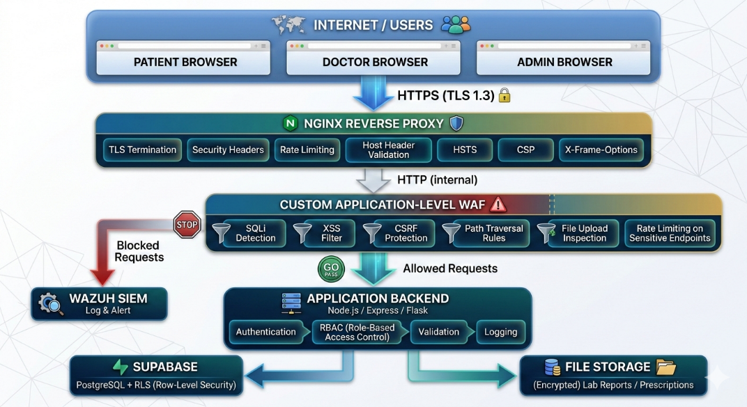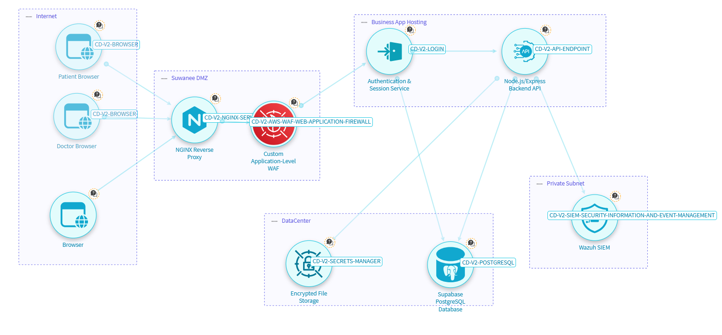

3.2 Data Flow Diagram (Level 0 — Context)
+-------------------+
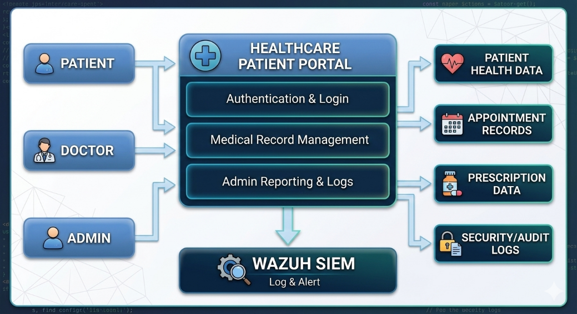

3.3 Data Flow Diagram (Level 1 — Key Processes)
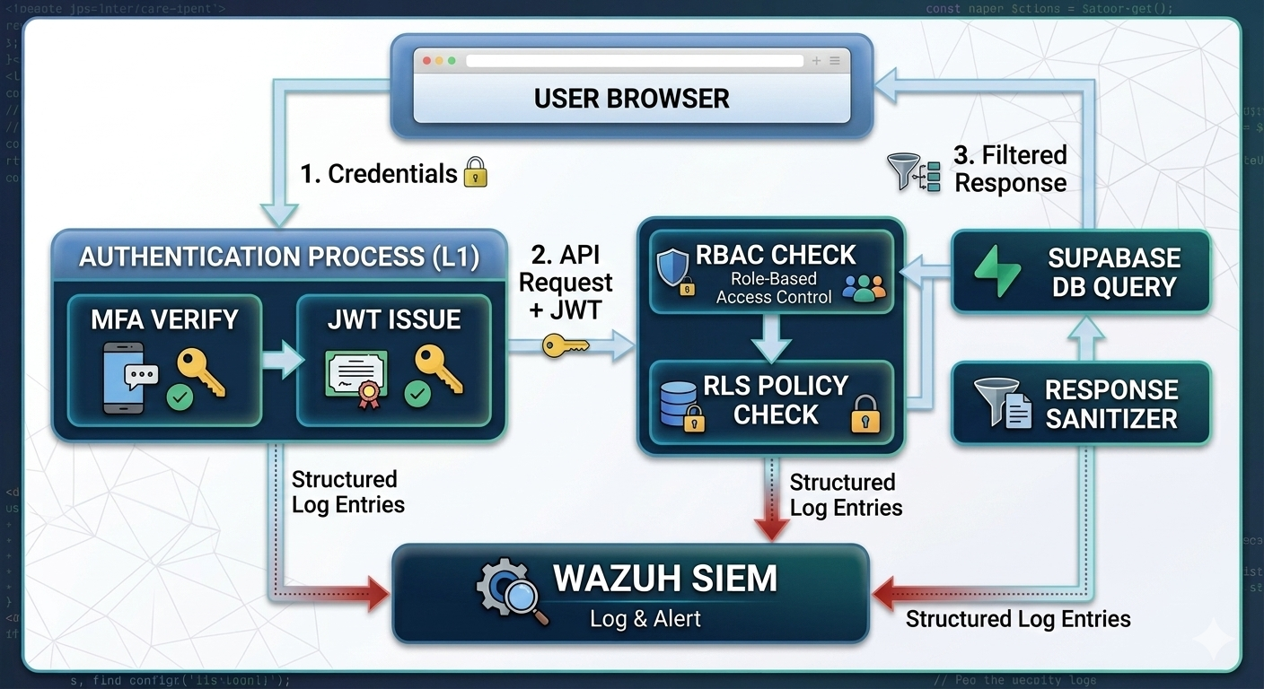

4. Trust Boundaries
Trust boundaries define the points where data moves between components with different levels of trust. All data crossing a trust boundary must be validated and authenticated.

Trust Boundary | Description | Data Crossing | Controls Applied
Internet → NGINX Proxy | External users / internet traffic enters system | All untrusted external requests | TLS termination, rate limiting, host header validation, security headers
NGINX → WAF | Proxied requests enter WAF filtering layer | HTTP requests from reverse proxy | SQLi, XSS, CSRF rule inspection, blocked request logging
WAF → Application Backend | Filtered requests reach business logic | WAF-approved HTTP requests | JWT authentication, RBAC enforcement, input schema validation
Application → Supabase DB | Backend queries the database | Server-side SQL queries | Parameterized queries, RLS policies, least privilege DB roles
Application → File Storage | Backend reads/writes file blobs | Lab reports, prescription files | AES-256 encryption at rest, access control checks before serving
Application → Wazuh SIEM | Logs forwarded to monitoring system | Structured security event logs | One-way log forwarding, log integrity, no PII in raw logs
User Browser → Application | Browser-side rendering and API calls | AJAX requests, form submissions | HTTPS-only, CSP headers, HttpOnly/Secure cookies, CORS policy

5. STRIDE Threat Analysis

5.1 STRIDE Methodology
STRIDE is a threat classification model developed by Microsoft. Each letter represents a category of threat:

STRIDE Category | Definition
S — Spoofing | Attacker impersonates a legitimate user, service, or data source.
T — Tampering | Unauthorized modification of data in transit or at rest.
R — Repudiation | User denies performing an action without the system being able to prove otherwise.
I — Information Disclosure | Exposure of sensitive data to unauthorized parties.
D — Denial of Service | Disruption of system availability, preventing legitimate users from accessing it.
E — Elevation of Privilege | Gaining unauthorized access to capabilities or data beyond the user's role.

5.2 STRIDE Threat Register
The following table applies STRIDE analysis to the Healthcare Patient Portal system, mapping each threat to its likelihood, and the security controls that mitigate it.

STRIDE Cat. | Threat Description | Attack Scenario | Likelihood | Mitigating Controls
Spoofing | Attacker impersonates a legitimate user or system component | Patient account takeover via credential stuffing | High | MFA (Email OTP), JWT + server session, bcrypt passwords, rate limiting on login
Spoofing | Attacker impersonates the backend API | Forged API responses to frontend | Medium | TLS 1.3 mutual validation, HTTPS-only, HSTS headers
Tampering | Modification of medical records or prescriptions in transit | MITM attack altering prescription data | High | TLS 1.3 in transit, AES-256 at rest, audit logs, input validation
Tampering | Parameter manipulation in API calls | Patient modifies appointment IDs to access others | High | RBAC + Supabase RLS, server-side authorization checks, parameterized queries
Repudiation | User denies performing a sensitive action | Doctor denies updating patient record | Medium | Structured audit logs (immutable), Wazuh SIEM, timestamped events with user ID
Information Disclosure | Unauthorized access to patient health records | Broken access control exposing PHI | Critical | Supabase RLS policies, RBAC, encrypted PHI (AES-256), secure error messages
Information Disclosure | Verbose error messages leaking system internals | Stack traces revealing DB schema | Medium | Custom error pages, no debug output in production, generic 404/500 responses
Information Disclosure | SQL Injection exposing database contents | Attacker extracts all patient records via injection | Critical | Parameterized queries, WAF SQLi rules, input validation, DB least privilege
Denial of Service | Brute force / credential stuffing on login endpoint | Bot floods login endpoint causing lockout | High | Rate limiting (global + per-IP), account lockout, WAF rate rules, CAPTCHA
Denial of Service | Resource exhaustion via large file uploads | Attacker uploads huge files to drain storage | Medium | File size limits, type validation, WAF file upload rules
Elevation of Privilege | Patient accesses doctor or admin dashboard | JWT role claim manipulation | Critical | Server-side role verification, RBAC on all endpoints, RLS DB policies
Elevation of Privilege | XSS leading to session token theft | Stored XSS in chat messages steals admin token | High | CSP headers, output encoding, input sanitization, HttpOnly/Secure cookie flags, WAF XSS rules

Note: Rows highlighted in red indicate Critical likelihood threats requiring immediate mitigation priority.

6. Attack Surface Analysis
The attack surface encompasses all points where the system accepts, processes, or exposes data. The following table enumerates each exposed surface, its risk level, and the controls protecting it.

Surface / Endpoint | Description | Risk Level | Security Controls
Login & Registration | Authentication endpoint | High | Rate limiting, MFA, bcrypt, account lockout
Password Reset | Token-based reset flow | High | One-time tokens, expiry, replay protection, audit logs
Patient Dashboard | Record view/edit APIs | Critical | RBAC, RLS, AES-256 at rest, audit logging
Doctor Dashboard | Patient record APIs | Critical | RBAC (assigned patients only), RLS, logging
Admin Dashboard | User management APIs | Critical | MFA enforced, RBAC, all actions logged
Appointment Booking | POST /appointments | Medium | Auth required, input validation, RBAC
Secure Messaging | Chat API endpoints | High | E2E encrypted storage, input sanitization, RBAC
File Upload | Lab reports / prescriptions | High | Type/size validation, encrypted at rest, WAF rules
API Endpoints | All REST API routes | High | JWT auth, schema validation, rate limiting
NGINX Proxy | TLS termination, routing | Medium | TLS 1.3, security headers, host header validation
WAF Layer | HTTP request filtering | Medium | SQLi/XSS/CSRF rule sets, SIEM integration
Supabase DB | PostgreSQL + RLS | Critical | RLS policies, parameterized queries, encryption

7. Key Data Flows and Security Controls
The following table documents the critical data flows within the system and the security controls applied at each stage.

Flow ID | Name | Path | Security Controls
DF-1 | User Login | Browser → NGINX → WAF → Auth Service → Supabase | Credentials encrypted in transit (TLS 1.3), rate limited, MFA verified, JWT issued
DF-2 | Patient Record Access | Browser → API → RLS Check → Supabase → API → Browser | RLS enforces user-only access, data encrypted at rest, audit log written
DF-3 | Doctor Views Patient | Doctor Browser → API → RBAC → RLS → Supabase → API | Only assigned patients returned, all access logged, no PHI leakage to other doctors
DF-4 | File Upload | Browser → WAF (type/size check) → API → Encrypted Storage | WAF validates file, API checks auth/RBAC, stored encrypted, path traversal prevented
DF-5 | Secure Message Send | Patient → API (auth check) → Encrypted DB → Doctor | Stored encrypted, RBAC ensures only participants can read, input sanitized
DF-6 | Admin Action | Admin Browser → MFA Check → API → Supabase → Audit Log | MFA required, all account changes logged to Wazuh, RBAC enforced
DF-7 | Password Reset | User Email → OTP Token → API → Token Validation → DB Update | One-time token, short expiry, replay protection, audit logged
DF-8 | Log Forwarding | App Backend → Structured Log → Wazuh SIEM | One-way forwarding, correlation rules for suspicious patterns, real-time alerting

8. Security Controls Summary
This section summarizes the security controls implemented across the system, organized by control category, and maps them to the STRIDE threat categories they address.

Control Category | STRIDE Addressed | Implementation Detail
Authentication & MFA | Spoofing, EoP | JWT + server-side sessions, Email OTP MFA, bcrypt password hashing, OAuth2 SSO, MFA enforced for admin
Authorization (RBAC + RLS) | EoP, Information Disclosure | Role-based access control on all API endpoints; Supabase Row Level Security for per-user/role DB isolation
Input Validation & Sanitization | Tampering, Info Disclosure | Strict schema validation on all inputs, parameterized SQL queries, output encoding to prevent XSS
Custom WAF | Tampering, DoS, Info Disclosure | Configurable rules for SQLi, XSS, CSRF, command injection, path traversal; rate limiting; file upload checks
Session Management | Spoofing, EoP | Short-lived JWT access tokens, refresh token rotation, inactivity timeout, HttpOnly/Secure cookie flags
Encryption | Information Disclosure | TLS 1.3 for all traffic in transit; AES-256 for PHI and files at rest
Security Headers (NGINX) | Tampering, Info Disclosure | CSP, HSTS, X-Frame-Options, X-Content-Type-Options, Referrer-Policy
Rate Limiting | Denial of Service | Global and per-endpoint rate limits; WAF rate rules on login, password reset, and high-privilege endpoints
Audit Logging & SIEM | Repudiation, all STRIDE | Structured logs for all auth events, record access, and admin actions; Wazuh SIEM with real-time alerting
Error Handling | Information Disclosure | Custom error pages (no stack traces), generic 404/500 responses, no internal details exposed
File Upload Security | Tampering, DoS | File type and size validation in WAF and backend; encrypted storage; path traversal prevention
Secure Messaging | Information Disclosure, Tampering | End-to-end encrypted message storage; RBAC restricts to conversation participants; input sanitized

9. Residual Risks and Assumptions

9.1 Residual Risks
The following threats have reduced but non-zero residual risk after controls are applied:
- Insider Threat (R6): RBAC and RLS limit data access, but a malicious admin with legitimate credentials remains a residual risk. Mitigated by audit logs, MFA, and Wazuh alerting on anomalous access patterns.
- Zero-Day Vulnerabilities: Novel exploits in dependencies (Supabase, Node.js, NGINX) cannot be fully pre-empted. Mitigated by dependency updates and security patching procedures.
- Social Engineering / Phishing: Users may be tricked into revealing credentials. Partially mitigated by MFA, but user awareness training is outside the technical scope.
- Session Token Leakage via XSS: Despite CSP and HttpOnly flags, advanced XSS payloads may attempt token exfiltration. Mitigated by WAF XSS rules and short token lifetimes.

9.2 Assumptions
- The NGINX and Supabase infrastructure are deployed on hardened servers with current security patches.
- Wazuh SIEM is operational and alert rules are configured before the portal goes live.
- Database credentials and JWT secrets are stored in environment variables, not in source code.
- HTTPS is enforced end-to-end; plain HTTP requests are redirected or rejected by NGINX.
- Admin accounts are provisioned manually and not self-registrable by users.

10. Conclusion
This threat model provides a structured analysis of the security threats facing the Secure Healthcare Patient Portal using the STRIDE methodology. The system's layered architecture — combining NGINX reverse proxy, custom WAF, RBAC, Supabase RLS, encryption, and Wazuh SIEM integration — provides defense-in-depth against the identified threat categories.

The most critical threats — unauthorized access to PHI, SQL injection, elevation of privilege, and XSS-based session hijacking — are addressed through multiple overlapping controls. The trust boundary analysis and data flow documentation provide a clear map of where data security must be enforced, guiding the implementation and testing phases of the project.

This document will be updated as the system evolves, with additional detail added during the implementation and security testing phases (Deliverable 2 onwards).

